**VIVEKANAND EDUCATION SOCIETY’S**

**INSTITUTE OF TECHNOLOGY**

**Department of Computer Engineering**



Project Report on

CAR PARKING AUTOMATION USING

INTERNET OF THINGS

In partial fulfillment of the Fourth Year, Bachelor of Engineering

(B.E.) Degree in Computer Engineering at the University of Mumbai for

Academic Year 2017-2018

**Submitted by**

Hanisha Jamtani (D17C, 24)

Meet Shah (D17C, 53)

Krishna Vanvari (D17C, 66)

**Project Mentor**

Mrs. Sunita Sahu

(2017-18)

**VIVEKANAND EDUCATION SOCIETY’S**

**INSTITUTE OF TECHNOLOGY**

**Department of Computer Engineering**



**Certificate**

This is to certify that ***Hanisha Jamtani, Meet Shah, Krishna Vanvari***of Fourth Year Computer Engineering studying under the University of Mumbai have satisfactorily completed the project on “***Car Parking Automation using IOT***” as a part of their coursework of PROJECT-II for Semester-VIII under the guidance of their mentor ***Prof. Mrs Sunita Sahu*** in the year 2017-2018.

This thesis/dissertation/project report entitled “***Car Parking Automation using IOT***” by ***Hanisha Jamtani, Meet Shah, Krishna Vanvari*** is approved for the degree of Computer Engineering.

|  |  |
| --- | --- |
| Programme Outcomes | Grade |
| PO1,PO2,PO3,PO4,PO5,PO6,PO7,  PO8, PO9, PO10, PO11, PO12  PSO1, PSO2 |  |

Date:

Project Guide:

------------------------------------------

**Project Report Approval**

**For**

**B. E (Computer Engineering)**

This thesis/dissertation/project report entitled “***Car Parking Automation using IOT***” by ***Hanisha Jamtani, Meet Shah, Krishna Vanvari*** is approved for the degree of Computer Engineering.

Internal Examiner

---------------------------------------------

External Examiner

---------------------------------------------

Head of the Department

-----------------------------------------------

Principal

-----------------------------------------------

Date:

Place:

**Declaration**

We declare that this written submission represents our ideas in our own words and where others' ideas or words have been included, we have adequately cited and referenced the original sources. We also declare that we have adhered to all principles of academic honesty and integrity and have not misrepresented or fabricated or falsified any idea/data/fact/source in our submission. We understand that any violation of the above will be cause for disciplinary action by the Institute and can also evoke penal action from the sources which have thus not been properly cited or from whom proper permission has not been taken when needed.

|  |  |
| --- | --- |
| -----------------------------------------  (Signature)  -----------------------------------------  (Name of student and Roll No.) | -----------------------------------------  (Signature)  -----------------------------------------  (Name of student and Roll No.) |
| -----------------------------------------  (Signature)  -----------------------------------------  (Name of student and Roll No.) | -----------------------------------------  (Signature)  -----------------------------------------  (Name of student and Roll No.) |

Date:

**ACKNOWLEDGEMENT**

We are thankful to our college Vivekanand Education Society’s Institute of Technology for considering our project and extending help at all stages needed during our work of collecting information regarding the project.

It gives us immense pleasure to express our deep and sincere gratitude to Assistant Professor        **Mrs. Sunita Sahu** (Project Guide) for her kind help and valuable advice during the development of project synopsis and for her guidance and suggestions.

We are deeply indebted to Head of the Computer Department **Dr.(Mrs.) Nupur Giri**and our Principal    **Dr. (Mrs.) J.M. Nair ,** for giving us this valuable opportunity to do this project.

We express our hearty thanks to them for their assistance without which it would have been difficult in finishing this project synopsis and project review successfully.

We convey our deep sense of gratitude to all teaching and non-teaching staff for their constant encouragement, support and selfless help throughout the project work. It is great pleasure to acknowledge the help and suggestion, which we received from the Department of Computer Engineering.

We wish to express our profound thanks to all those who helped us in gathering information about the project. Our families too have provided moral support and encouragement at several times.

**Computer Engineering Department**

**COURSE OUTCOMES FOR B.E PROJECT**

Learners will be to,

|  |  |
| --- | --- |
| **Course Outcome** | **Description of the Course Outcome** |
| CO 1 | Able to apply the relevant engineering concepts, knowledge and skills towards the project. |
| CO2 | Able to identify, formulate and interpret the various relevant research papers and to determine the problem. |
| CO 3 | Able to apply the engineering concepts towards designing solution for the problem. |
| CO 4 | Able to interpret the data and datasets to be utilized. |
| CO 5 | Able to create, select and apply appropriate technologies, techniques, resources and tools for the project. |
| CO 6 | Able to apply ethical, professional policies and principles towards societal, environmental, safety and cultural benefit. |
| CO 7 | Able to function effectively as an individual, and as a member of a team, allocating roles with clear lines of responsibility and accountability. |
| CO 8 | Able to write effective reports, design documents and make effective presentations. |
| CO 9 | Able to apply engineering and management principles to the project as a team member. |
| CO 10 | Able to apply the project domain knowledge to sharpen one’s competency. |
| CO 11 | Able to develop professional, presentational, balanced and structured approach towards project development. |
| CO 12 | Able to adopt skills, languages, environment and platforms for creating innovative solutions for the project. |

**Abstract**

The **Internet of Things** (**IoT**) is the network of physical devices, vehicles, home appliances, hardware, tools and other items embedded with electronics, software, sensors, actuators, and connectivity which enables these objects to connect and exchange data.

Our project Car Parking Automation using IOT represents the design and implementation of the prototype developed of the car parking automation system based on IOT, that allow the drivers to park their cars efficiently, within no time hence saving time and fuel. The proposed system consists of IR sensors, embedded web-server and a mobile application. First the user has to follow the traditional process of registration and then login through Android application. The status of the parking slots is detected by the sensors and is updated periodically on the web-server. Low cost sensor network is deployed on the prototype which represents a parking area. The user can book a vacant slot and can also pay online through his wallet. The database is updated accordingly and all the information such as empty slots, reserved slots, peak parking hours, etc. is notified to the user with the help of the application. This information is sent using Wi-Fi networks in real-time through the embedded web server to the Android application to the user.

**TABLE OF CONTENTS**

|  |  |  |
| --- | --- | --- |
| **SR. NO.** | **CONTENTS** | **PAGE NO.** |
| **1** | **Chapter 1: Introduction** |  |
| 1.1 | Introduction | **10** |
| 1.2 | Motivation | **10** |
| 1.3 | Drawback of the Existing System | **10** |
| 1.4 | Problem Definition | **11** |
| 1.5 | Relevance | 11 |
| **2** | **Chapter 2: Literature Survey and Patents** |  |
| 2.1 | Papers | **12** |
| 2.2 | Patents | **16** |
| **3** | **Chapter 3: Requirements** |  |
| 3.1 | Functional Requirements | **20** |
| 3.2 | Non Functional Requirements | **21** |
| 3.3 | Constraints | **21** |
| 3.4 | Hardware and Software Requirements | **21** |
| 3.5 | Techniques utilized till date for proposed system | **22** |
| **4** | **Chapter 4: Proposed Design** |  |
| 4.1 | System Block Design | **23** |
| 4.2 | Modular Representation of the Proposed System | **24** |
| 4.3 | Detail Design of the System | **25** |
| 4.4 | Project scheduling and tracking using gantt chart | **31** |
| **5** | **Chapter 5: Implementation** |  |
| 5.1 | Algorithms of the modules developed | 33 |
| 5.2 | Evaluation of the Developed System | 33 |
| **6** | **Chapter 6:Testing** | **36** |
| **7** | **Chapter 7:Result Analysis** |  |
| 7.1 | Simulation Model | 38 |
| 7.2 | Screenshots of User Interface (UI) | 38 |
| 7.3 | Graphical Outputs | 40 |
| **8** | **Chapter 8: Conclusion** |  |
| 8.1 | Limitations | 41 |
| 8.2 | Conclusion | 41 |
| 8.3 | Future Scope | 42 |
| **9** | **Chapter 9: References** | **44** |
| **10** | **Chapter 10: Appendix** | **46** |
| 10.1 | Paper I |  |
| 10.2 | Paper II |  |

**LIST OF FIGURES:**

|  |  |  |
| --- | --- | --- |
| **FIG NO.** | **DESCRIPTION** | **PAGE NO.** |
| 3.1 | Basic Structure of Proposed System | 22 |
| 4.1 | Block diagram of System | 23 |
| 4.2 | Modular Representation of the Proposed System | 24 |
| 4.3.1 | Data Flow Diagram Level 0 | 25 |
| 4.3.2 | Data Flow Diagram Level 1 | 26 |
| 4.3.3 | Data Flow Diagram Level 2 | 27 |
| 4.3.4 | Flow Chart | 28 |
| 4.3.5 | ER Diagram | 30 |
| 4.4 | Project scheduling and tracking using gantt chart | 31 |
| 7.2.1 | Login and Registration UI | 38 |
| 7.2.2 | Booking UI | 39 |
| 7.2.3 | Backend UI | 39 |
| 7.3.2 | Scatter Plot and Histogram | 41 |
| 7.3.3 | Reservation Record | 40 |
| 7.3.4 | Data loaded in R Studio | 40 |

**CHAPTER 1: INTRODUCTION**

* 1. **Introduction**

There has been a great demand of some automated system that will prove to be beneficial to the users. Our project aims to find a solution to this problem where due to increasing population in metropolitan cities, the number of cars on the roads increase, simultaneously resulting a scarcity of the availability of the parking slots. Our system gives an automated approach which involves minimal human intervention. Our objective is to come up with this system which will be economical, easy to understand and requires less effort.

* 1. **Motivation**

Since the proposition of Smart Cities in the country, there has been a growing need of automation and introduction to new systems that can reduce human involvement. This has motivated and created a need to develop a change in the parking system making it more convenient and fast. Albeit, several parking solutions are available, this system integrates all problems into one single idea that can be permanently embedded as a solution. The system will incorporate different modules like parking availability calculation, proximity estimation and payment service.

* 1. **Drawback of the existing system**
* As the driver spends great amount of time in search of a slot, the manual system proves to be **time consuming**.
* Similarly, searching for a slot will also result in **traffic congestion**.
* If a driver roams around to find a safe slot, it may result in **wastage of fuel** eventually leading to **pollution**.
* **Unstructured payment system**, which is tedious and time consuming.
  1. **Problem definition**

The issue of parking in metropolitan cities has created a havoc. Even before leaving homes, people give a second thought to take their vehicles along with them as they get worried about finding a safe slot to park.To create a car parking system that can function automatically and efficiently allow the owners of the cars to find parking spots that are close to their choice of entrance. The system should enable car owners to check the availability of parking spaces using an application. The project aims to provide users with information about peak hours of visit in a particular facility using the data recorded by the sensors. Also, the system should reduce the time of entrance to parking lot and allow users to make payments using the application itself.

* 1. **Relevance**

A step needs to be taken at this hour. In a globalising world where everything is getting automated, transformation from a manual system to a modernised one sounds to be a great idea. People can find a parking slot in any facility at their homes itself. In big cities, finding a proper parking slot is a tedious task. This problem will keep increasing as the population is growing day after day. With the advent of new technologies, people have a wide range of choices in the market. Hence the number of vehicles on road elevates. The ratio increases but with a declivity of vehicle parking slots. Nevertheless, as people roam around in search an appropriate parking slot, great amount of fuel is used, leading to air pollution. Hence, this system will help eradicate this.

**Chapter 2: Literature Survey**

**2.1 Papers and Books**

**2.1.1** **Smart Routing: A Novel Application of Collaborative Path-finding to Smart Parking Systems by Callum Rhodes, William Blewitt, Craig Sharp, Gary Ushaw and Graham Morgan**

**ABSTRACT --**We utilise collaborative path-finding to improve efficiency of smart parking systems and therefore reduce traffic congestion in metropolitan environments, while increasing efficiency and profitability of parking garages. A significant portion of traffic in urban areas is accounted for by drivers searching for an available parking space. Many cities have adopted a parking guidance and information system to try to alleviate this traffic congestion. Typically these systems entail informing the driver of the whereabouts of an available space, reserving that space for the specific driver, and providing directions to reach the destination. Little or no account is taken of how much congestion will be caused by multiple drivers being directed to the same car-park concurrently. We introduce the concept of collaborative path- finding to the problem. We simulate a smart parking system for an urban environment, and show that a novel approach to collaboratively planning paths for multiple agents can lead to reduced traffic congestion on routes toward busy parking areas, while reducing the amount of time when parking spaces are vacant, thereby increasing the revenue earned.

**INFERENCE** - Utilise collaborative path-finding to improve efficiency of smart parking systems and therefore reduce traffic congestion in metropolitan environments.

**2.1.2 Cloud Based Intelligent Transport System by K.Ashokkumar, Baron Sam , R.Arshadprabhu, Britto**

**ABSTRACT-** The advances in cloud computing and web of things (IoT) have provided a promising chance to resolve the challenges caused by the increasing transportation problems. We tend to gift a unique multi-layered conveyance knowledge cloud platform by exploitation cloud computing and IOT technologies to resolve the challenges caused by the increasing transportation issues. We present a novel multi-layered vehicular data cloud platform by using cloud computing and IOT technologies. Two innovative vehicular data cloud services, an intelligent parking cloud service and a vehicular data mining cloud service in the IoT environment are also presented reviews.

**INFERENCE-** A tendency to gift a unique standard and multi-layered conveyance information cloud platform supporting cloud computing and IoT technologies.

**2.1.3** **Efficient Automated Smart Parking System using IOT Technologies by S. M. Bhadkumbhe , Anuj Narayan , Dnyaneshwar Narayan , Sarfraj Shaikh & Yogesh Kunjir.**

**ABSTRACT**: The number of non-public vehicles usage is increasing. Individuals like personal vehicles to commute than rely upon public transportation. Finding a parking zone in most metropolitan areas, particularly throughout the push hours, is troublesome for drivers. it's usually frustrating for drivers to seek out parking areas, and parking itself is a problem in nearly each major town within the world. In this paper, an automatic automobile parking application is proposed that regulates the amount of cars to be place on selected park. The proposed application keep tracks of free and occupied by parking slots. The user can reserve a parking slot by selecting the area. An estimated buffer time will be calculated between the source and destination places. The reservation will be cancelled if the user reached the parking slot after the buffer time. The payment of usage of parking service will be done using wallet.

**INFERENCE-** The proposed application is based on the client-server architecture. The client is provided with an interactive Android based user interface for the process of pre-booking of parking slot. The server side processing will be enabled using Java and MySQL.

**2.1.4 A Cloud Based Car Parking Middleware for IoT-Based    Smart Cities : Design and Implementation by Zhanlin Ji , Ivan Ganchev , Mairtin O’Droma , Li Zhao , and Xueji Zhang**

**ABSTRACT-** This paper presents the generic concept of using cloud-based intelligent car parking services in smart cities as an important application of the Internet of Things (IoT) paradigm. This type of services will become an integral part of a generic IoT operational platform for smart cities due to its pure business-oriented features. A high-level view of the proposed middleware is outlined and the corresponding operational platform is illustrated. To demonstrate the provision of car parking services, based on the proposed middleware, a cloud-based intelligent car parking system for use within a university campus is described along with details of its design, implementation, and operation. A number of software solutions, including Kafka/Storm/Hbase clusters, OSGi web applications with distributed NoSQL, a rule engine, and mobile applications, are proposed to provide ‘best’ car parking service experience to mobile users, following the Always Best Connected and best Served (ABC&S) paradigm.

**INFERENCE-** This paper is based on three layers : Sensors, Communication and application. The paper criticised about the image processing algorithms and suggested a better sensor based solution.

**2.1.5 A Cloud Based Smart Car Parking System Based on Internet of Things. Thanah Nam Pham , Ming-Fong Tsai , Duc Binh Nguyen , Chyi-Ren Dow ,  Der-Jiunn Deng**

**ABSTRACT-** This paper introduces a novel algorithm that increases the efficiency of the current cloud-based smart-parking system and develops a network architecture based on the Internet-of-Things technology. This paper proposed a system that helps users automatically find a free parking space at the least cost based on new performance metrics to calculate the user parking cost by considering the distance and the total number of free places in each car park. This cost will be used to offer a solution of finding an available parking space upon a request by the user and a solution of suggesting a new car park if the current car park is full. The simulation results show that the algorithm helps improve the probability of successful parking and minimizes the user waiting time. We also successfully implemented the proposed system in the real world.

**INFERENCE-** This paper represented the system for street parking using a mathematical cost effective model.

**2.1.6 Vision-Guided Automatic Parking for Smart Car by  Jin Xu, Guang Chen and Ming Xie.**

**ABSTRACT-** Presents our work on automatic parking of a smart car that relies on vision to estimate free parking slots. All problems involved in implementing an automatic parking behavior are discussed. Solutions are given together with experimental results obtained from real data.

**INFERENCE-** This paper provided insights to different methodologies that should be implemented to deploy the system. The paper talks about how can car parking be automated and why will it be beneficial.

**2.1.7 Automatic Smart Parking System using Internet of Things (IOT) by Mr. Basavaraju S R.**

**ABSTRACT-** Internet of Things (IOT) plays a vital role in connecting the surrounding environmental things to the network and made easy to access those un-internet things from any remote location. It’s inevitable for the people to update with the growing technology. And generally people are facing problems on parking vehicles in parking slots in a city. In this study we design a Smart Parking System (SPS) which enables the user to find the nearest parking area and gives availability of parking slots in that respective parking area. And it mainly focus on reducing the time in finding the parking lots and also it avoids the unnecessary travelling through filled parking lots in a parking area. Thus it reduces the fuel consumption which in turn reduces carbon footprints in an atmosphere.

**INFERENCE-** Proposed a system implemented using IOT and cloud computing so as to reduce traffic congestion and emission of fuels on a larger scale.

**2.1.8 IoT Based Smart Parking System Using RFID by Prof.S.S.Thorat , Ashwini M , Akanksha Kelshikar , Sneha Londhe, Mamta Choudhary**

**ABSTRACT-** With the exponential increase in the number of vehicles and world population day by day, vehicle availability and usage on the road in recent years, finding a space for parking the bike is becoming more and more difficult with resulting in the number of conflicts such as traffic problems. This is about creating a reliable system that takes over the task of identifying free slots in a parking area and keeping the record of vehicles parked very systematic manner. This project lessens human effort at the parking area to a great extent such as in case of searching of free slots by the driver and calculating the payment for each vehicle using parking area. The various steps involved in this operation are vehicle identification using RFID tags, free slot detection using IR sensors and payment calculation is done on the basis of period of parking and this is done with the help of real time clock.

**INFERENCE-** RFID and IR sensors used for gathering data of the parking slots available. This is an IOT based smart car parking system.

**2.1.9** **Internet of Things Approach to Cloud-based Smart Car Parking by Yacine Atif a,*, Jianguo Dinga , Manfred A. Jeusfelda**

**ABSTRACT-** Concerns for parking are becoming imminent to best support the urban core. These persistent parking problems could be turned into new opportunities, brought by current trends in meeting the globally connected continuum. This paper reveals a work-in-progress to capitalize on private land properties for parking, in order to relieve stress on public agencies, create new sources of revenue, and enlist new entities in the intermediary market. These intermediaries, labelled as Parking Service Providers (or PSPs) play a broker role through advertising parking lots on a shared cloud platform. To streamline these business collaborations and related processes, physical parking lots are augmented with Internet connectivity allowing cloud-provided applications to congregate these lots into a larger inventory. The Internet of Things (IoT) paradigm expands the scope of cloud-based intelligent car parking services in smart cities, with novel applications that better regulate car-parking related traffic. This paper presents a work-in-progress agenda that contributes to new business solutions and state-of-the-art research impacts. We reveal a multi-layered system of PSP-business model through interdisciplinary research blocks where original results are expected to be made at each layer.

**INFERENCE-** A middleware that masks the heterogeneity and distribution of connected objects (such as parking sensors). While the IoT layer provides the infrastructure for sensing devices and communication technologies, the middleware layer provides an open interface between the infrastructure layer and the application layer.

**2.2 Patents**

**2.2.1 PATENT NAME: Parking Management System (US 7391339B2)**

**INFORMATION:**

|  |  |
| --- | --- |
| **Publication number** | US 7,391,339 B2 |
| **Publication type** | **Grant** |
| **Application number** | 11/114,615 |
| **Publication date** | Jun. 24, 2008 |
| **Filing date** | Apr. 25, 2005 |
| **Priority date** | Sep. 1, 2005 |
| **Also published as** | US6,885,311. |
| **Inventors** | Charles K. Howard, Kenroy Cayetano, Olufemi Omojola . |

**Abstract** -- The systems described herein include one or more wireless vehicle detectors, along with a distributed parking payment system such as parking meters or a paystation. Information from the payment system and the vehicle detectors may be combined to determine when a parking violation occurs, or is about to occur. This information may then be transmitted through a communication system to a parking enforcement officer, along with information about the geographic location of the violation. The information may also, or instead be transmitted to a parking payer to notify the payer of an impending infraction so that the payer may purchase additional parking time before the violation.

**2.2.2 PATENT NAME –** **Automated Parking System: US 8,632,290 B2**

**INFORMATON:**

|  |  |
| --- | --- |
| **Publication number** | **US20160300392 A1** |
| **Publication type** | **Application** |
| **Application No:** | 13/008,578 |
| **Publication date** | Jul. 28, 2011 |
| **Filing date** | Jan. 18, 2011 |
| **Inventors** | Christopher Alan . |
| **Original Assignee** | Auto Parkit, LLC, Los Angeles, CA (US) . |

**Abstract --** An automated parking system for a parking structure includes a controller which receives a vehicle loading request from a vehicle customer. A loading bay accepts the vehicle and transfers to the parking system. Equipment is provided for transferring the vehicle horizontally and vertically through the parking system. The vehicle parking system includes a rack structure that is integrated as part of the parking structure.

**2.2.3 PATENT NAME: Bibliographic Data:  Car Parking System**

**INFORMATION**

|  |  |
| --- | --- |
| **Publication number** | US005336031A |
| **Publication type** | **Application** |
| **Application No:** | 3,563 |
| **Publication date** | Aug. 9, 1994 |
| **Filing date** | Jan. 13, 1993 |
| **Inventors** | Zeev Golan |

**Abstract --** A parking system for vehicles includes a vehicle support platform adapted to support a vehicle over a parking area and having a rear end portion permitting travel of a vehicle there across, a front end portion, and side portions extending longitudinally between the rear and front end portions; and support apparatus for the platform located at a predetermined end portion of the parking area and adapted to engage the platform front end portion only. The support apparatus also includes lifting apparatus which is operative to cause an initial pivoting of the platform about the rear end portion such that the front end portion of the platform becomes elevated above the rear end portion, and which is also operative to cause an additional pivoting of the platform about the front end portion to elevate the rear end portion of the platform relative to the front end portion, thereby bringing the platform into a raised position and provide vertical clearance between the platform and the parking area that is sufficient to enable entry of a vehicle beneath the platform. The support apparatus supports the platform in the raised position, such that the front end portion of the platform is in vertical registration with the forward-most portion of the predetermined end portion of the parking area whereat the support apparatus is located; and the lifting apparatus is also operative to lower the platform to a lowered position where at the rear end portion thereof is vertically adjacent to a ground surface, to allow travel of a vehicle between the platform and the ground surface.

**2.2.4 PATENT NAME: Bibliographic Data : Vehicle parking system**

**INFORMATION**

|  |  |
| --- | --- |
| **Publication number** | US005336031A |
| **Publication type** | **Application** |
| **Application No:** | 3,563 |
| **Publication date** | Aug. 9, 1994 |
| **Filing date** | Jan. 13, 1993 |
| **Inventors** | Torrent Hjelmvik |
| **Assignee** | **odul-SystemSwedenAB,Järfäla (SE) .** |

**Abstract** -- A parking system in which a mobile telephone can be used to commence and terminate a parking period. A user sends at least one code to a receiving computer at the commencement and termination of a parking period via a mobile telephone system or a permanent telephone system. When a user first connects to the parking system by telephone in order to be able to park the user's vehicle within the system and to communicate parking commencement and termination times with the aid of a telephone, either a pay meter, a cash card terminal, or some corresponding device is caused to read mechanically a cash card that is owned by the user and that is accepted by the parking system as a means of payment. The data read from the cash card is stored in a database in a parking system computer, and at least one user-specific reference is entered and stored in the database and is associated with the cash card data for subsequent identification of the user and for billing the user for parking.

**Chapter 3: Requirements**

Requirements analysis, also called requirements engineering, is the process of determining user expectations for a new or modified product. These features, called requirements, must be quantifiable, relevant and detailed. A requirement gathering process should be carried out to know the current system and the need to reform it. Our proposed system gives a fully automated solution to the problem of finding an appropriate parking slot. It overcomes the issues faced due to the manual parking system. For our proposal to work in an efficient manner, some inputs are needed to guide us. This can be achieved by requirement gathering. With the help of this, the usual trends of parking patterns are known which will help us to develop an efficient algorithm. Nevertheless, the suitable software and hardware tools are analyzed. The appropriate sensors are known which will be used to detect a free space in the parking area.

The requirements for our proposed system name “CAR PARKING AUTOMATION USING IOT comprises of:-

**3.1 Functional Requirements**

1. Sensor based system that detects vehicles in a parking lot and streams the data via a wireless network.
2. Server Based architecture that stores the data and allows basic processing of data.
3. Detect user location and notify the closest vacant parking facility.
4. To provide an application that allows the users to view the availability of parking in a facility.
5. A System that predict the best parking spot based on the user requirement like entering a particular area of the mall.
6. Provide users with sufficient information and relevant directions to their parking spot.
7. Slot assigned to the user according to the type of vehicle.
8. Users can make payments for parking using the application directly using in-built money transfer apps.
9. User can reserve the parking slot in the desired parking area.

**3.2 Non-Functional Requirements**

1. Accessibility- Application should work on every mobile device.
2. Modifiability- The application should easily modify the data and update the database.
3. Security- Our system should ensure that the user integrity is maintained.
4. Reliability- Even after the device hangs or stops working due to some reason, a backup should take place.
5. Scalability- The system should be capable to handle a large amount of slot data in the database.

**3.3 Constraints**

1. Testing sensors after deployment at a certain facility during course of project development isn’t possible. Testing can be made possible using prototype models.
2. This project will be limited to an android application. In order to deploy, there must be an IOS version/web version of the application to be accessible by visitors, as there is huge number of IPhone users in the market as well.
3. Significant results can be evaluated only from implementing this project on a large scale. Hence analytical results cannot be obtained from this project.
4. Setting up network for data transfer.
5. Deployment of the Hardware.

**3.4 Hardware and Software Requirements**

**Software:**

Software technology:

1. Arduino IDE

Android development:

1. Windows 7 or 8
2. Android Studio
3. Java

**Software Apps and Online Services:**

1. Bluehost Cpanel (Server Management System)
2. Android Studio

**Hardware**:

1. SparkFun SparkFun Block for Intel® Edison – Arduino
2. Ultrasonic Sensor - HC-SR04 (Generic)
3. IR receiver (generic)
4. Buzzer

**Technology:**

* 1. Android Development
  2. Internet of Things (IOT)

**3.5 Techniques Utilized Till Date For The Proposed System:**

* A unique standard and multi-layered conveyance information cloud platform supporting cloud computing and IOT technologies.
* Providing the client with an interactive Android based user interface for the process of pre-booking of parking slot. This motivated us to enhance and add more functions to the application such as to choose the type of vehicle the user had.
* Image processing used for the recognition of the license plate number to store in the cloud. This is used for the payment purposes.
* Identification of the appropriate sensors which will be used for collecting information about the empty spaces in the parking area.

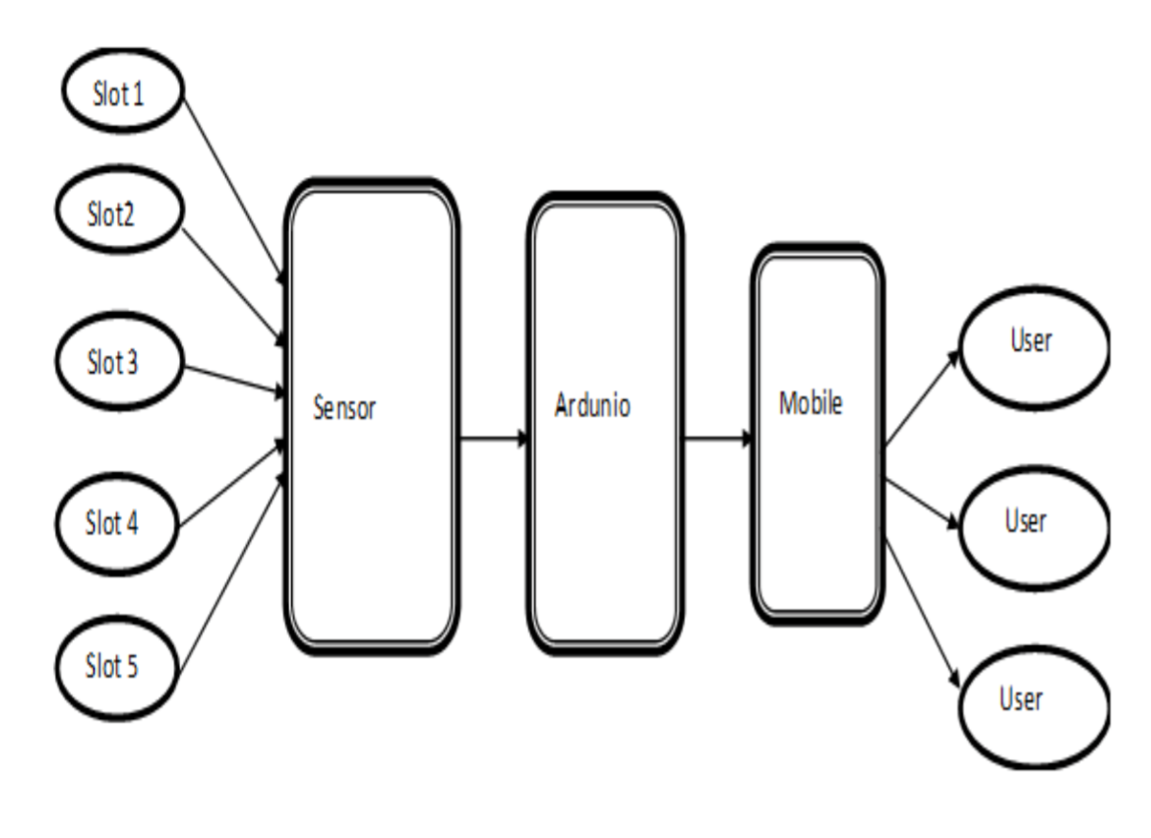

Figure 3.1

The figure above shows the basic structure of our proposed system. The sensors will sense whether the parking slots are free or no.

**CHAPTER 4: Proposed Design**

**4.1 Block Diagram of System**

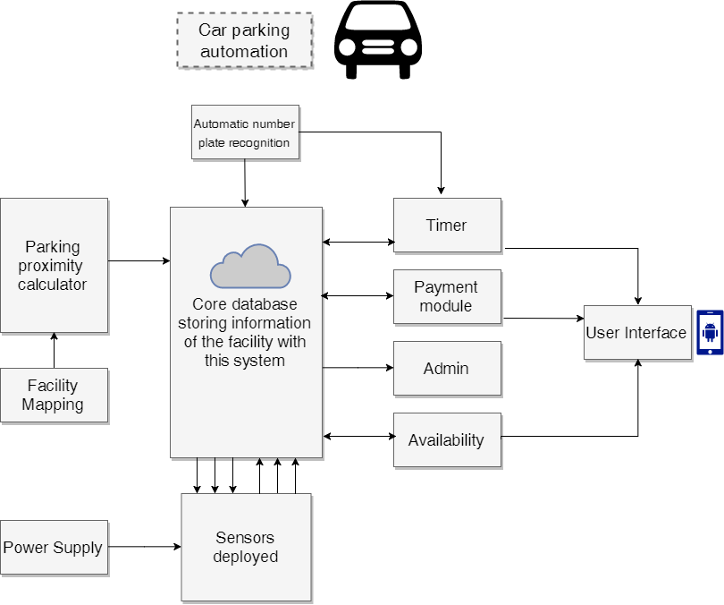

Figure 4.1

A diagram showing in schematic form the general arrangement of the parts or components of a complex system or process, such as an industrial apparatus or an electronic circuit is known as a **BLOCK DIAGRAM.**

The above diagram shows the representation of our proposed system. The sensors are deployed and provided with a power supply. The whole system will work efficiently if the core database is stores all the information needed. Firstly, the mapping of the facility’s parking area is done. When the user wants to find a slot which is close by, proximity calculator is used which will calculate the distance of the closest slot. All this is updated in the database. The license plate number is given to the database which is stored along with the arrival and the departure time.

Timer, payment module and the availability module has a two way relationship with the core as these information keeps changing depending on the user/vehicle owner.

The owner of the vehicle will be updated with all the information which will be provided by the cloud database.

Finally, after all the data gathered from the database, the user will be notified through the user interface.

**4.2 Modular Diagram Representation of the Proposed System**

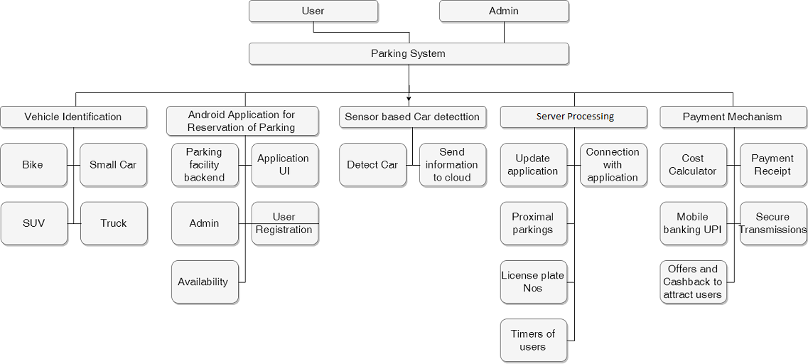

Figure 4.2

Modular design is a design approach that subdivides a system into smaller parts called modules that can be independently created and then used in different systems. A modular system can be characterized by functional partitioning into discrete scalable, reusable modules; rigorous use of well-defined modular interfaces; and making use of industry standards for interfaces.

We’ve five major modules in our proposed project which are as follows:

1. Vehicle Identification
2. Sensor based car detection
3. Server based Processing
4. Android Application
5. Payment Gateway

Each module has several sub-modules that perform respective functions and form the entire system. The sub-modules are created integrated to obtain the most benefits from the resources that will be utilised to implement this project and form a network responsible for automating the parking system.

Considering the existing systems and the costs encountered for executing the project, these modules will be the most efficient solution till date and be fully capable of dealing with difficulties that might arise during its implementation.

* 1. **Detailed Design Of The System**
     1. **Data Flow Diagram**

**LEVEL 0:**

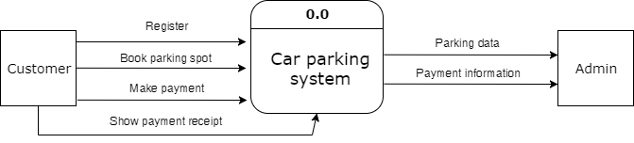

Figure 4.3.1

The customer will register with the system for once and create an account. After logging in, the user will search for a parking slot and if a favourable one is available, he/she can book a slot immediately. Before the user leaves the premises, payment has to be done. The amount to be paid is sent to the user and then it is paid. For confirmation of the payment, the user is provided with a payment receipt.

**LEVEL 1:**

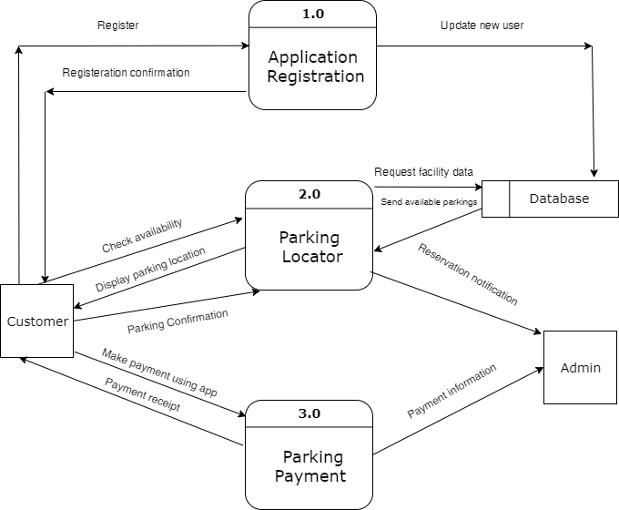

Figure 4.3.2

There are 3 main modules in this DFD are nearest parking calculator, License plate recognition and time calculator. The customer specifies the location they wish to visit and accordingly the nearest parking slot will be allocated. A confirmation will be sent to the customer. All these tasks are performed by the nearest parking system. Before assigning a slot, this module requests the database to provide the information of the nearest slot available. The database is updated accordingly. The license plate recognition, with the help of image processing scans the number of the license plate.

Time calculator gives a buffer time to the user to enter and exit the facility.

After the license plate number is scanned, the user is notified with the confirmation of the slot.

The license plate number and different time for different users is updated in the database.

**LEVEL 2:**

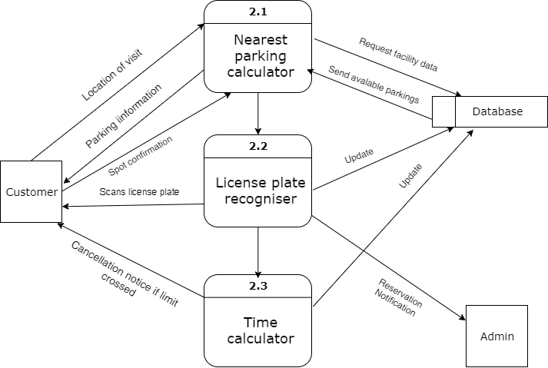

Figure 4.3.3

A new user will first register with the system. After registering, the user will be notified with a confirmation.

With the help of parking locator the user will be provided with the availability of the slots and will display the parking location. The user will be navigated to the spot.

A different module will be made which will facilitate the online parking. The user will make payment through the application and the user will receive a payment receipt.

All these actions performed will be updated in the database and the user will be informed time to time.

**4.3.2 Flowchart Diagram**

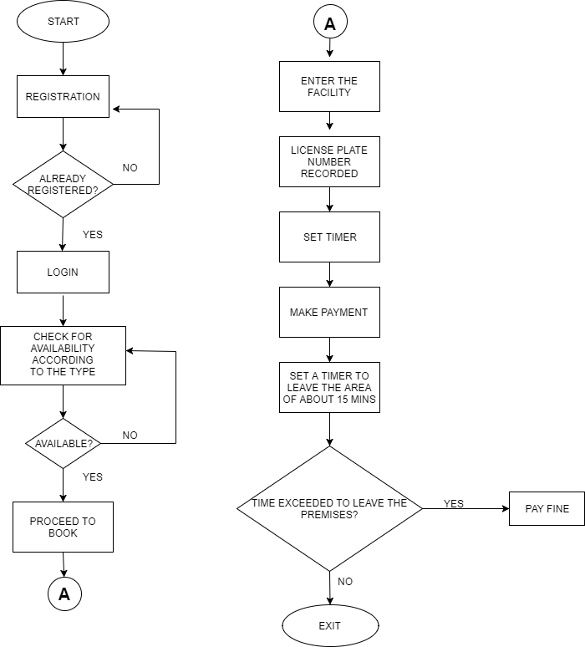

Figure 4.3.4

The above diagram shows the basic flow of system. The user will first register with the application if he/she are the new users. If the user already has an account, only logging in is needed. After logging in the user will search for a parking slot according to the type of vehicle. If the parking slot is not available the user can wait or try again. If a slot is available, the user can proceed to book.

When the user enters the premises, the license plate number of the user will be captured.

A timer is set which will not stop until the user makes the payment.

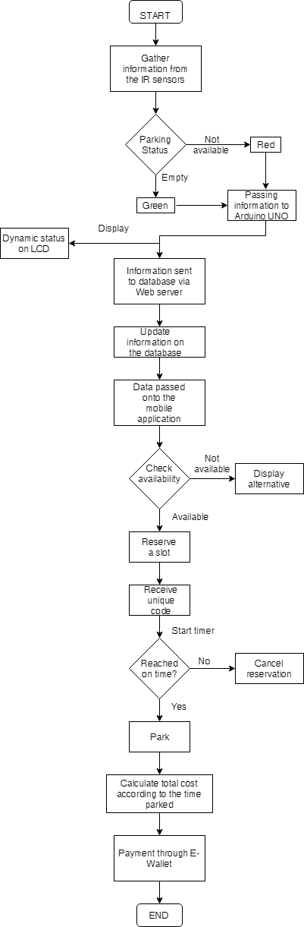

Figure 4.3.5

**4.3.3. ER Diagram**

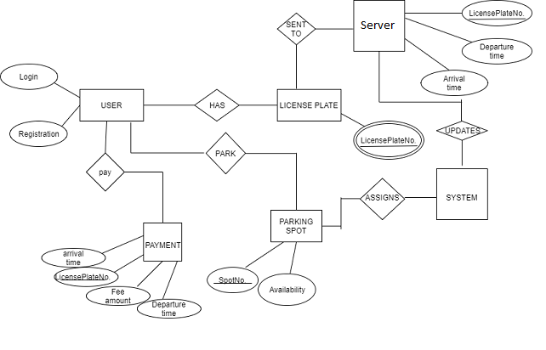

Figure 4.3.6

An entity relationship diagram consists of the objects represented in the system and its attributes. Attributes are a part of a particular entity.

User is an entity that consists of attributes login and registration. Every vehicle of the owner will have a unique license plate number that will recorded through image processing with the use of camera. The user will park the vehicle on the spot provided according to its availability. Here also, the user will be given a spot number.

The license plate number will be sent to the cloud where it will be stored along with the arrival and the departure time.

The cloud will keep updating the system about the different license plate numbers and timings.

Accordingly, the system will assign a slot to the user.

* 1. **Project Scheduling & Tracking Using Timeline/ Gnatt Chart**

This approach has been defined for the development of the various stages and modules of the Project. Gnatt chart also helps us identify and create deadlines for each module to be developed. It is a sequential flow of events and operations to be carried out to build this project. Given below is the deadline and stages that have been followed while creating this system.

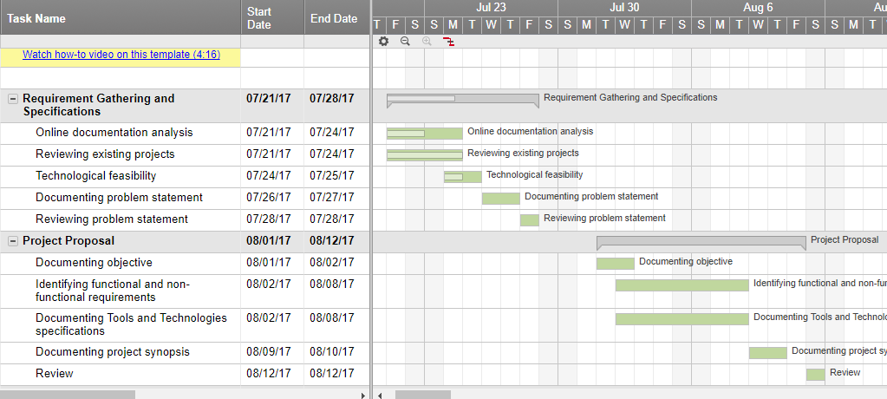

Figure 4.4.1

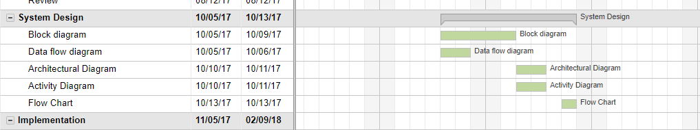

Figure 4.4.2

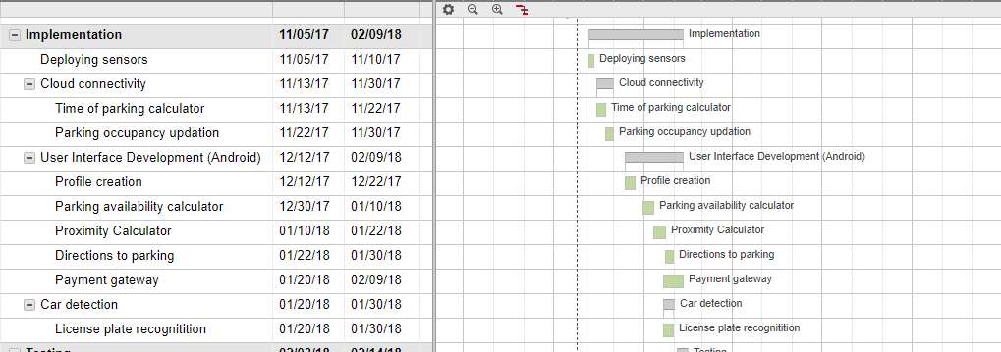

Figure 4.4.3

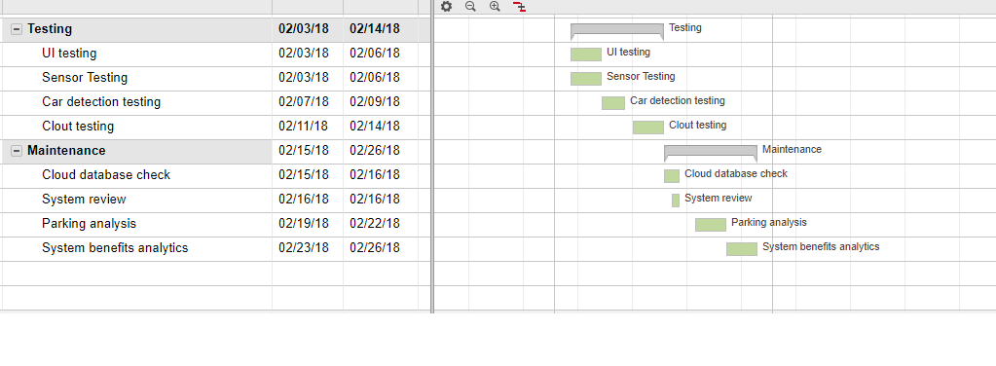

Figure 4.4.4

**Chapter 5: Implementation**

* 1. **Algorithms of the Respective Modules Developed**

1. New simple Algorithms were developed on the basis of the requirements in this project. The system created efficient algorithms to generate bills for parking after reservation and calculating and deducting the amounts from the registered users account.
2. An algorithm was created to check the authenticity of the User. It required the user to enter the unique code created in reference to his/her booking of the parking slot. The user is required to enter the code in order to get an entry into the parking lot.
3. Also this particular entry code is also responsible for calculating the duration for which the user uses the services of the parking lot. Based on this, the user can be charged appropriately.
4. A module is created in this project that has live interaction with the user. This algorithm serves the purpose of providing live data to the user whenever the user requests for it. The information from the sensors is conveyed in an instant to the user informing the user which parking slots are available for him/her to book.
   1. **Evaluation of the Developed System**

Project implementation is a phase where the visions and plans becomes a reality. This is logical conclusion, after evaluating, deciding, visioning, planning for a project. Implementation means carrying out activities that have been planned. The basic requirement for starting the implementation process is to have the work plan ready and understood by all the actors involved.

We started our implementation by writing and executing the code for license plate recognition in Matlab and then developed the prototype of the IoT based Car parking system.

The tools or applications included:

**Arduino Uno**: Used as a hardware module for IoT projects.

**IR sensors**: Used for detecting the object/car.

This section rightly explains the steps we carried out for the implementation of the prototype, having a parking lot connected to a working application. This prototype stands as an exclusive proof for the system in the real-time environment.

The sequence of flow of the functionality of the system and the objective of each step during the course of implementation is explained below:

1. An android application is downloaded by the user for the reservation purpose. We have developed the application on Android Studio Development Kit, which enables parking availability check, reservation and cancellation to the registered user. The user maintains a profile within the application stores the user history.
2. The IR proximity sensors detect the availability of the slots and update the database which eventually notifies the application.
3. 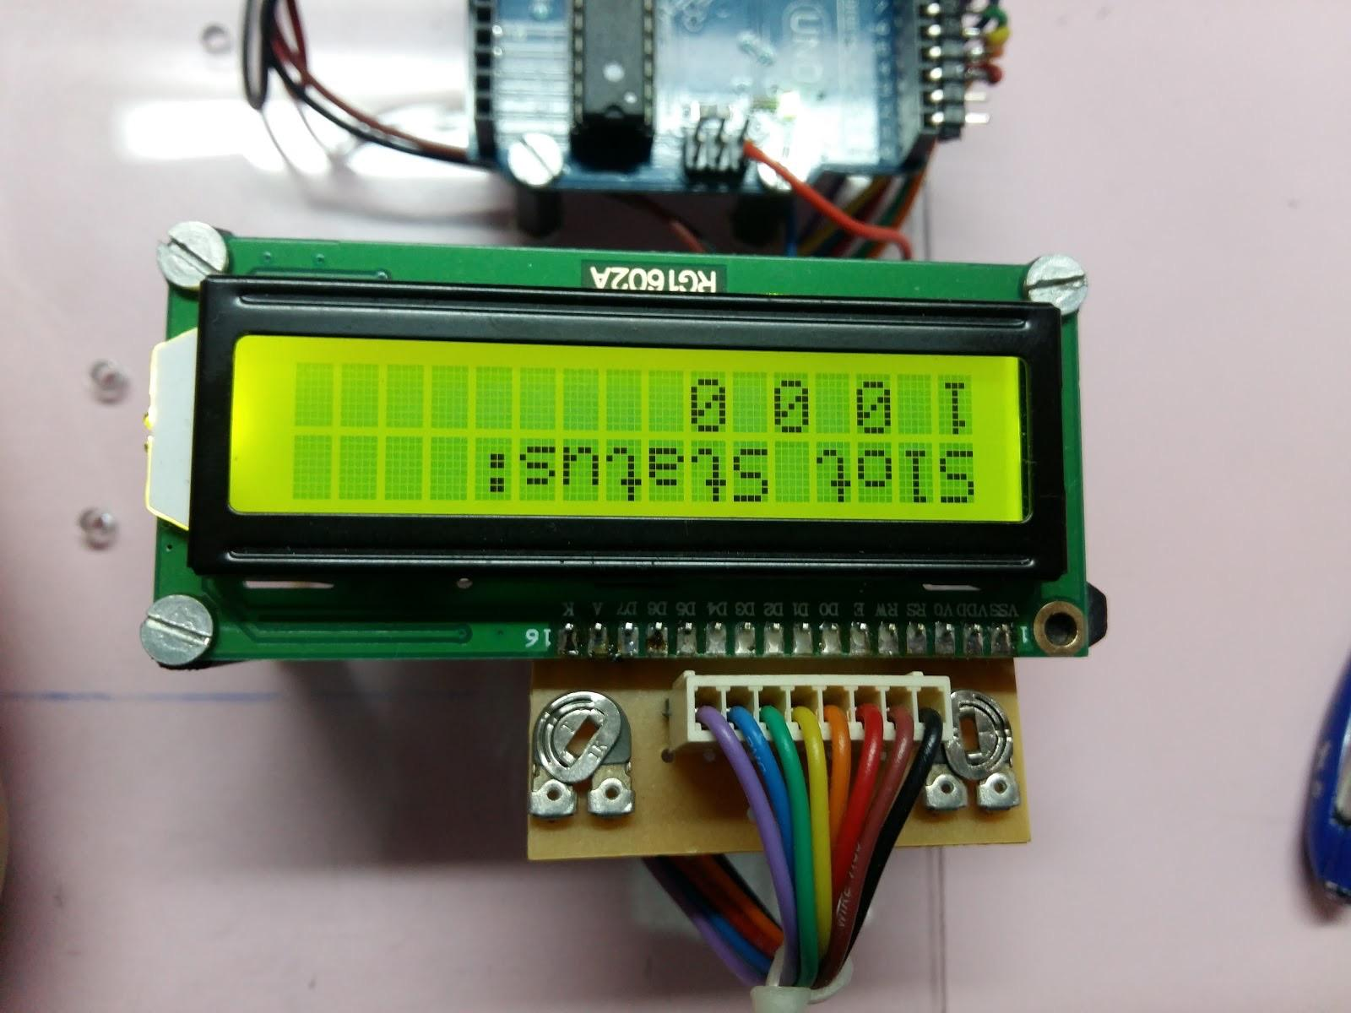Arduino UNO is a computer in itself which sends the data detected from the sensors to the database through http server. The Arduino code has been developed on Arduino Create Agent.

Figure 5.1

1. The prototype has a display connected to Arduino which gives live availability status. The image below tells that 1 indicates that the parking slot 1 is full and 0 signifies that slot 2, 3, 4 are empty.
2. All the gathered data from the Arduino and the sensors is passed onto the database server. Microsoft SQL server .NET Framework is used at the                             backend to store the user information along with the slot availability including entry and exit time of the car.
3. After the user selects a slot for parking, he/she needs to reach the premises within a predefined time. The functionality of timer is also added which is used for the cancellation purpose.

The car owner is also provided with a unique code which is used for authentication

1. The amount to be paid is calculated on the basis of the total time the car stayed in the premises.
2. E-Wallet is used for the purpose of payment wherein the user maintains a certain amount of balance which gets deducted in every visit.
3. When there is no sufficient balance in the account, the user is notified to add electronic cash into the wallet. This functionality proves to be easy and quick to the car owners.
4. According to analytics, if a particular area is full, an alternative parking area will be suggested to the user which will be nearby.
5. This facility ensures that the car gets a slot even in highly congested areas.
6. Moreover, analytics is carried out, telling about the peak hours and days. The application user will be notified about the same.

**CHAPTER 6: TESTING**

**What is testing?**

Testing is measures taken to check the quality, performance, or reliability before putting it into use. Testing assesses the quality of the product. In terms of Software, Software testing can be defined as it is a process of executing a program or application with the intent of finding the software bugs. It can also be stated as the process of validating and verifying that a software program or application or product: Meets the business and technical requirements that guided its design and development. Some tools can also be used for testing of a software. Some specialised persons can also be called for testing of our application who knows how to test an application or who is specialised in this field and knows how to deal with an application.

He knows all the weak points where the software usually malfunction.

**Why is software testing required?**

Testing is required for an effective performance of software application or product. It's important to ensure that the application should not result into any failures because it can be very expensive in the future or in the later stages of the development. Basic things when software testing required to:

* Point out the [defects](http://istqbexamcertification.com/what-is-defect-or-bugs-or-faults-in-software-testing/) and errors that were made during the [development phases](http://istqbexamcertification.com/what-are-the-software-development-life-cycle-sdlc-phases/).
* Make sure of the Customer’s reliability and their satisfaction in the application.
* Deliver a high quality product or software application which requires lower maintenance cost and hence results into more accurate, consistent and reliable results.
* Meet the requirements that guided its design and development.
* respond correctly to correct inputs and prompts error message on incorrect input
* Perform its function within an acceptable time.

**What is Validation?**

The process of evaluating software during or at the end of the development process to determine whether it satisfies specified requirements. Validation checks that the product design satisfies or fits the intended use (high-level checking), i.e., the software meets the user requirements. This is done through [dynamic testing](https://en.wikipedia.org/wiki/Dynamic_testing) and other forms of review. In terms of modelling, Validation is the process of determining the degree to which a model, and their associated data are accurate representations of the real world from the perspective of the intended use.

**What is Verification?**

The process of evaluating software to determine whether the products of a given development phase satisfy the conditions imposed at the start of that phase. In terms of modelling, Verification is the process of determining that a [computer model](https://en.wikipedia.org/wiki/Computer_model)  implementations and their associated data accurately represent the conceptual description and specifications.

In other words, software verification is ensuring that the product has been built according to the requirements and design specifications, while software validation ensures that the product meets the user's needs, and that the specifications were correct in the first place.

* Validation: Are we building the right product?
* Verification: Are we building the product right?

Our system performs the verification of the user at two stages. First is the user login stage and second is when the user has made a booking and is about to enter the parking lot. User request is verified and then the user is allowed to enter.

**Test Case:**

A test case is a set of conditions under which we can determine whether a system under test satisfies requirements or works correctly. The process of developing test cases can also help find problems in the design of an application. Various tests were performed on the booking activity of the application to determine the reliability of the system. Given below is the figure of the booking activity on which the tests were performed.

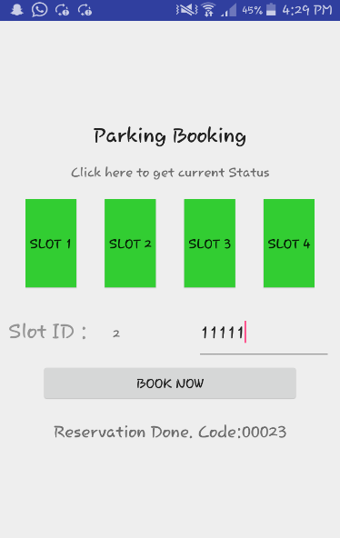

Figure 6.1

**CHAPTER 7:**

* 1. **Simulation Model**
* An automated parking system application is developed in order help the car owners to get a desirable parking spot in a crowded area. The user can view the parking lot as well as get information about availability via the user interface. The user can request the application to get the current status of parking lot by the click of a button.
* The user can ask the application to book a parking spot of choice after entering its vehicle ID. In case of the parking spot being already booked, the user is duly notified. Also a case of double booking has been tested to not occur since a session is created and assigned to only a single user for a particular parking spot.
* The user will be charged on the basis of the duration for which the car is inside the parking lot which is done using the backend processor of the system. The user is required to enter authentication code that is generated for each parking booking at the entry and exit.
* The application also provides a list of parking lots in the area that will be equipped with this system. The user has to select the facility and then make the booking.
  1. **Screenshots of the UI and Backend**

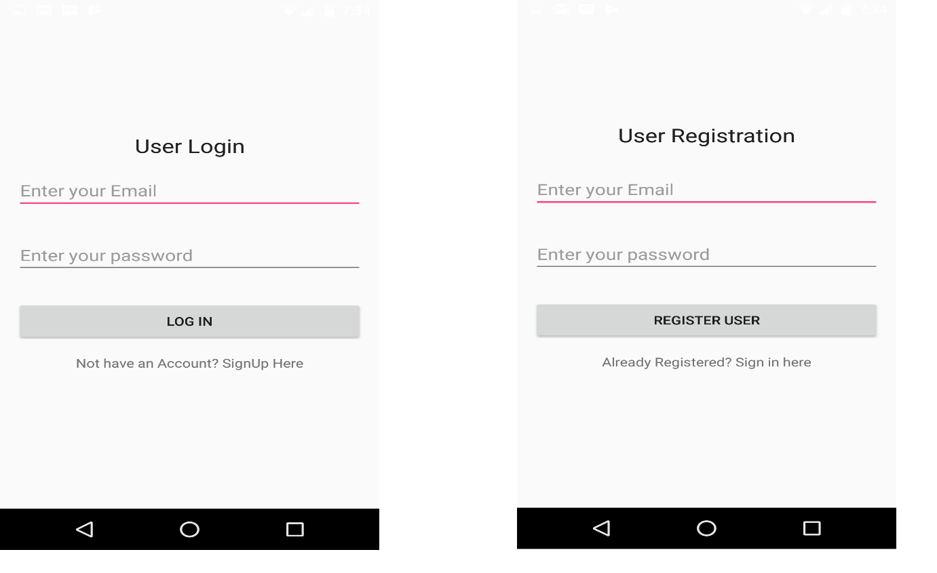

Figure 7.2.1

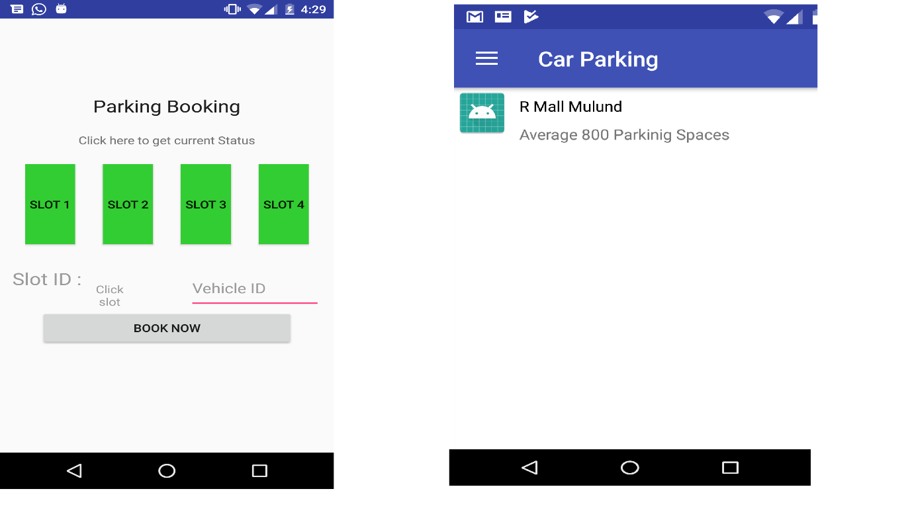

Figure 7.2.2

Figure 7.2.1 displays the registration and the login page of the application. The right side of figure 7.2.2 displays the first activity of the application i.e. a list containing the facilities that are equipped with this system. The left image shows the booking UI of the system through which the parking spots can be selected and booked.

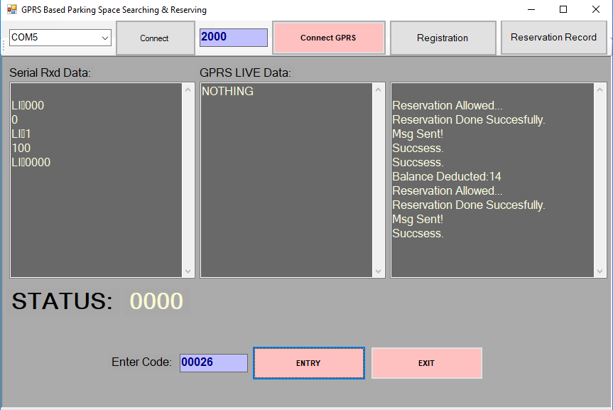

Figure 7.2.3

The above figure displays the backend UI of the system. The backend is developed on the VB .Net software acting as the interface between the Arduino hardware and the android application using a server link. All activities and communication occurring between these elements are displayed here showcasing how the system is working.

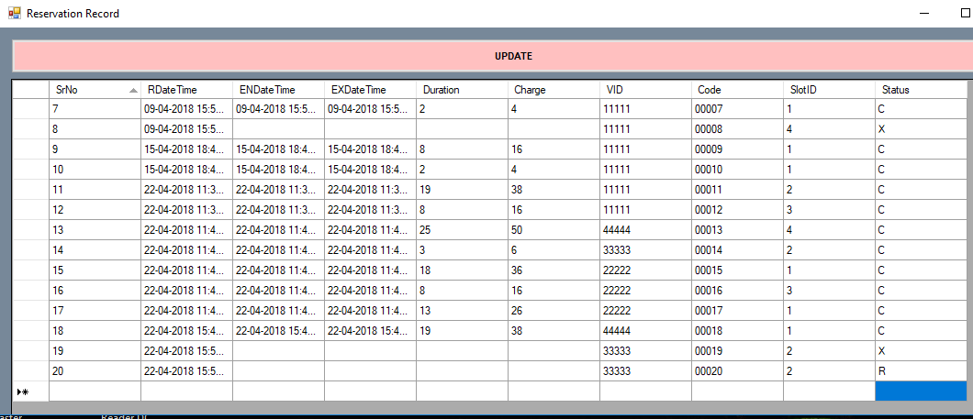

Figure 7.2.4

This shows the reservation record of the users. Whenever a booking operation is performed, an entry is made in this table which is used to calculate the duration of stay, payment and also perform user authentication.

* 1. **Graphical Outputs**
     1. **Data loaded in R Studio**

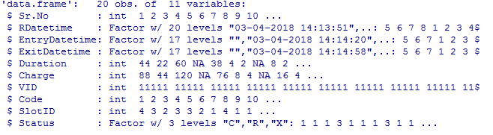

Figure 7.3.1

Experiments conducted on the prototype version enabled us to produce certain meaningful insights that can be obtained from a live system. Figure on the right is a scatter plot of the duration for which the vehicles entered and stayed in the parking lot. This information can be useful to create specific business plans

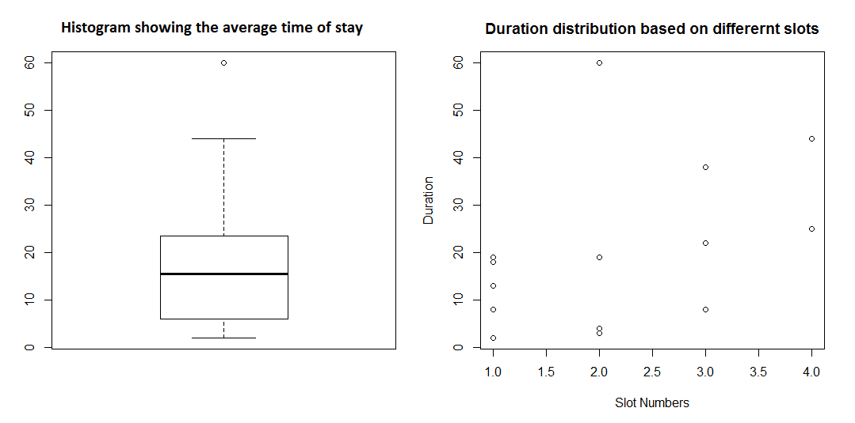

Figure 7.3.2

Figure on the left shows a histogram plot to in correspondence to the duration of stay of each vehicle. Further, the booking data of the user can enlighten with the peak hour information and the best and worst time of the day to visit a particular parking facility.

E-wallet facility using the application is also tested successfully using the prototype. The user has to have a minimum balance of 50 in order to make the booking. Also, payment calculation is done by the system and a bill is generated for the same.

**CHAPTER 8: CONCLUSION**

**8.1 Limitations**

The prototype developed by us is having a limited number of parking slots i.e. 4 parking slots. The implementation cost of our proposed system in a mall would be much higher. Sensors used in prototype are much cheaper compared to the sensors that will be deployed in the mall.

**8.2 Conclusion**

This report consists the proposition of a Vehicle Parking Automation system which facilitates the user to book a parking spot with the help of an application. It also searches for the nearest parking spot with the help of sensors and cloud computation. The online payment option eliminates the need for human intervention and making the system automated in real sense. Also the proposed system is very economical and easy to implement as it does not involve any expensive hardware or devices. The spot will be allocated according to the size of the vehicle. To sum up, the automated system of vehicle parking promises to be beneficial in all terms.

On a larger scale, this project has several benefits and will be of high significance in facilities where incoming and outgoing traffic is considerably high during all times of the day, airport for example.

Metropolitan cities are in high need of such a system which promises to be completely automated. This paper presents a solution to an ongoing crucial problem in our everyday lives related to manual vehicle parking. We tried to implement a system which clears out the issue by making the whole system automated. This system stands out to be completely feasible and makes the task of the user quite convenient. The functionalities such as E-Wallet is a unique element created for the vehicle owner’s to make this system reliable and user friendly. Moreover, the environmental factors are also affected in a good way, saving fuel and avoiding pollution. The proposed system in highly flexible, thereby making it suitable for enhancements. Additional functionalities like number plate recognition at the entrance for authentication can be deployed easily with the help of a camera. This system can be shifted to a cloud based system for large number of vehicle owners using the application.

**8.3 Future scope**

The system prototype developed by us can be implemented in a facility on a large scale and maps and parking directions can be integrated in our android application.

The system prototype is a model version of a real project that can be developed in any parking lot with any size of parking slots.

The system can be introduced in smaller parking areas as well as on the streets where getting parking in a hustled up city like Mumbai is pretty difficult.

As of now, the proposed system proposes payment gateway using the user interface. A fully developed system can have a dynamic payment module that could charge according to the peak hours and peak days, data for which can be obtained from the system itself.

Also, to be able to make the system fully functional, an ios version of the software or a website providing similar features must be created.

**CHAPTER 9: REFERENCES**

**REFERENCE PAPERS AND THESIS:**

1. I. F. Akyildiz, W. Su, Y. Sankarasubramaniam, E. Cayirci, "Wireless sensor networks: a survey," Computer Networks, vol. 38. Pp. 393 - 422,2002.
2. S. M. Bhadkumbhe , Anuj Narayan , Dnyaneshwar Narayan ,          Sarfraj Shaikh & Yogesh Kunjir.”Efficient Automated Smart Parking System using IOT Technologies” - *Imperial Journal of Interdisciplinary Research (IJIR) Vol-3, Issue-4, 2017*
3. Q. Wu, C. Huang, S. Y. Wang, W. C. Chiu, and T. Chen, "Robust Parking Space Detection Considering Inter-Space Correlation," iEEE international Conference on Multimedia and Expo, Beijing, China, July 2 - 5, pp. 659-662,2007.
4. M. Caliskan, D. Graupner, and M. Mauve, "Decentralized discovery of free parking places," in VANET '06: Proceedings of the 3rd international workshop on Vehicular ad hoc networks, New York, NY, USA, pp. 30 -29,2006
5. C. Laugier and F. Thierry. “Sensor-based control architecture for a car-like vehicle.” *Proceedings of IEEE/RSJ International Conference on Intelligent Robots and Systems, Volume 1, pages 216 –222, 1998.*
6. J. P. Benson, T. O'Donovan, P. O'sullivan, U. Roedig, and C. Sreenan,"Car-Park management using wireless sensor networks," in Proceedings of 31" IEEE coif. Local Computer Networks, Tampa, pp. 588-595. 2006.
7. G. Yan, W. Yang, D. B. Rawat and S. Olariu, "Smart Parking: A Secure and Intelligent Parking System," iEEE intelligent Transportation Systems Magazine, vol. 3(1), pp. 18 - 30,2011.
8. C. Laugier and F. Thierry. “Sensor-based control architecture for a car-like vehicle.” *Proceedings of IEEE/RSJ International Conference on Intelligent Robots and Systems, Volume 1, pages 216 –222, 1998.*
9. Shinde Smita N., Shinde Komal V., Nagpure Rashmila D. , Tupkar Avanti S., Prof. Ankoshe M. S "An Android Application for Parking Management and Dissemination System” - *International Journal of Scientific and Research Publications, Volume 2, Issue 10,Oct-2012-1 ISSN 2250-3153*
10. J. Dongjiu Geng, Yue Suo, Yu Chen, Jun Wen, Yongqing Lu, “Remote Access and Control System Based on Android Mobile Phone”, *Journal of Computer Applications, 2011.*
11. Mr. Basavaraju S R,”Automatic Smart Parking System using Internet of Things (IOT)”,*International Journal of Scientific and Research Publications, Volume 5, Issue 12, December 2015 629 ISSN 2250-3153*
12. *Hongwei Wang and Wenbo He, "A Reservation-based Smart Parking System," The First international Workshop on Cyber-Physical Networking Systems, pp. 70 I - 706, 2011.*
13. C. Laugier and F. Thierry. “Sensor-based control architecture for a car-like vehicle.” *Proceedings of IEEE/RSJ International Conference on Intelligent Robots and Systems, Volume 1, pages 216 –222, 1998.*
14. M.O. Reze M.F. Ismail A.A. Rokoni M.A.R. Sarkar, “Smart parking system with image processing facility”, *I.J. Intelligent Systems and Applications, 2012.*
15. Swee Meng Wong and Ming Xie.” Vision Functions for the Guidance of Smart Vehicle”.*Proceedings of the 9th International Conference on Advanced Robotics ('99 ICAR), Tokyo, Japan, October 25-27 1999.*
16. J. Wolff, T. Heuer, H. Gao, M. Weinmann, S. Voit and U. Hartmann, "Parking monitor system based on magnetic field sensors," *IEEE Conf. Intelligent Transportation Systems, 2006.*
17. Callum Rhodes, William Blewitt, Craig Sharp, Gary Ushaw and Graham Morgan “Smart Routing: A Novel Application of Collaborative Path-finding to Smart Parking Systems” *2014 IEEE 16th Conference on Business Informatics.*
18. K.Ashokkumar, Baron Sam , R. Arshadprabhu  , Britto,”Cloud Based Intelligent Transport System”,*2nd* *International Symposium on Big Data and Cloud Computing (ISBCC’15)*
19. Thanah Nam Pham , Ming-Fong Tsai , Duc Binh Nguyen , Chyi-Ren Dow ,  Der-Jiunn Deng, “A Cloud Based Smart Car Parking System Based on Internet of Things”, *Digital Object Identifier 10.1109/ACCESS.2015.2477299.*
20. C. Laugier and F. Thierry. “Sensor-based control architecture for a car-like vehicle.” *Proceedings of IEEE/RSJ International Conference on Intelligent Robots and Systems, Volume 1, pages 216 –222, 1998.*
21. J. P. Benson, T. O'Donovan, P. O'sullivan, U. Roedig, and C. Sreenan,"Car-Park management using wireless sensor networks," in Proceedings of 31" IEEE coif. Local Computer Networks, Tampa, pp. 588-595. 2006.

**CHAPTER 10: APPENDIX**

|  |  |
| --- | --- |
| **SR. NO.** | **CONTENTS** |
| 1 | Paper I |
| 2 | Plagiarism Report (1.1) |
| 3 | Certificates |
| 4 | Paper I |
| 5 | Plagiarism Report (2.1) |
| 6 | Certificates |